**From:** Rajendaran, Dhandapani <Dhandapani.Rajendaran@VerizonWireless.com>   
**Sent:** Monday, April 02, 2018 10:06 PM  
**To:** VZW UAT AUTOMATION <VZW.UAT.AUTOMATION@VerizonWireless.com>  
**Subject:** Appium Swipe commands that can be used generic

Team,

Some useful tips like to share,

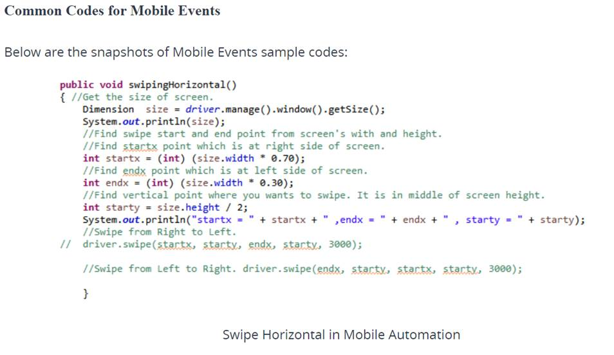

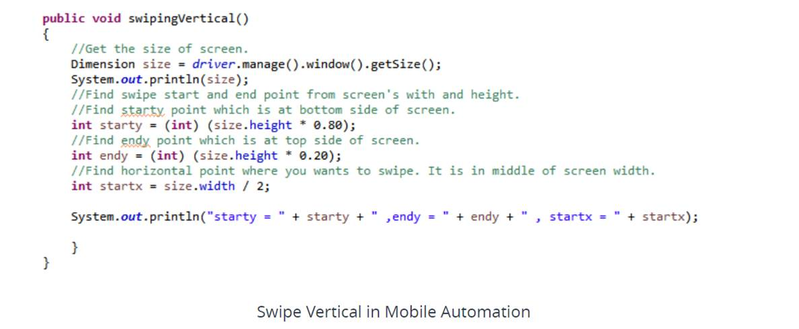

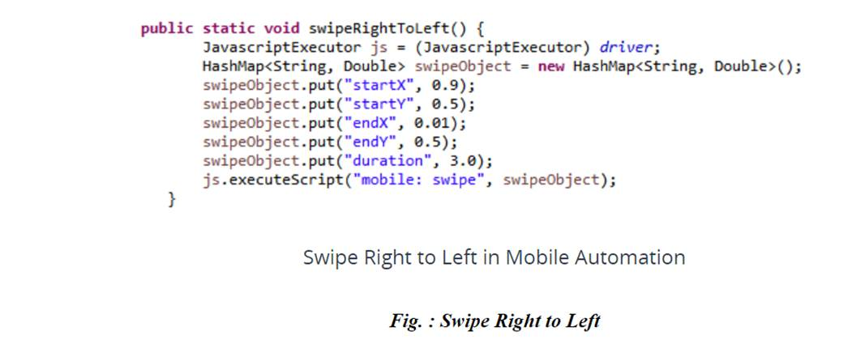

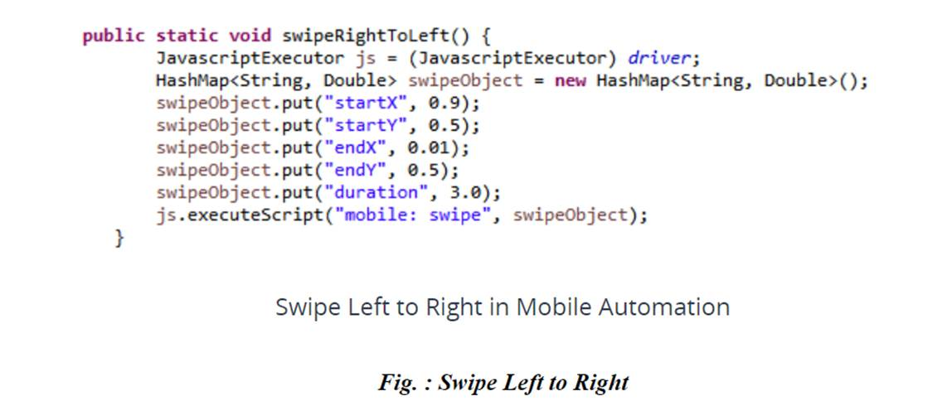

Regards,

DP